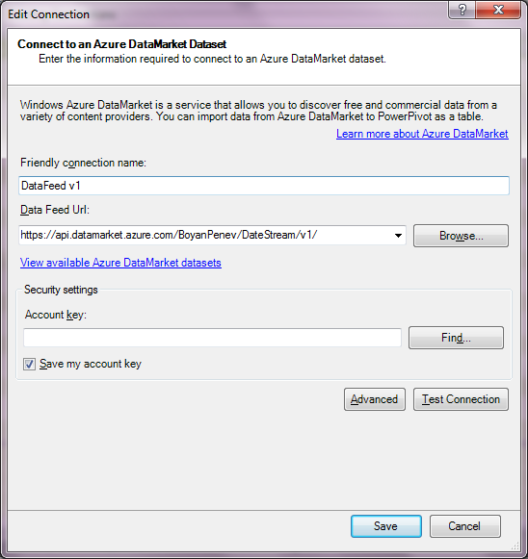

https://api.datamarket.azure.com/BoyanPenev/DateStream/v1/

My account key OOmxHRP7zmH54K6JmQj+DKP51vwZJLtKR2OqnPvtAxM

Useful links

<https://www.youtube.com/watch?v=EC4AJynwulg>

<http://www.powerpivotpro.com/>

DAX Examples

Calculate Qty per day:

=SUM(Invoices [Quantity Ordered])/COUNTROWS(DISTINCT(Invoices[Date Issued]))

Calculate Amount for a particular category:

=CALCULATE(Sum([Quantity Ordered]), Invoices[Product Category] = "Vegetables")

Calculate Month to Date of Invoice Amount:

=CALCULATE(sum(Invoices[InvoiceAmount]), DATESMTD(Invoices[Date Issued]))

Calculate How much each client is as a percentage of the total:

=SUM(Invoices[InvoiceAmount])/CALCULATE(SUM(Invoices[InvoiceAmount]), ALL(Invoices[Client]))